LAB-07

TASK 1: Paper Selection

Selected Domain: Industrial Systems (Industry 4.0 & Manufacturing)

Research Questions (RQs):
- RQ1: What are the primary Big Data challenges (volume, velocity, variety) currently impacting decision-making in Industry 4.0 environments?
- RQ2: Which machine learning and knowledge-based methodologies are most effective for resolving constraints and modeling complex temporal industrial data?
- RQ3: How does the integration of unstructured technical knowledge with dynamic time-series data influence manufacturing process efficiency and product quality?

Search Query:

(("Industry 4.0" OR "Industrial Systems") AND ("Big Data" OR "Data Analytics") AND ("Challenges" OR "Limitations") AND ("Knowledge Graph" OR "Machine Learning") AND ("Collaborative Design" OR "Decision Support"))

Selected Papers (2023–2026 Focus):
- SLR Papers:
  - Zheng et al. (2021): "The applications of Industry 4.0 technologies in manufacturing context: a systematic literature review".
  - Zhou & Sheu (2025): "The use of Generative Artificial Intelligence (GenAI) in operations research: review and future research agenda".

Research Papers (2024–2026):
  - Zheng et al. (2025): "Knowledge-based approach for resolving constraint conflicts in collaborative engineering design".
  - Zhou et al. (2023): "Semantic-aware event link reasoning over industrial knowledge graph embedding time series data".
  - Wang et al. (2026): "Comparative Analysis of Strategies for Enhancing LLM Performance in Cartography" (Geospatial/Industrial application).
  - Zhang et al. (2026): "Leveraging AI and Big Data Analytics to model career progression" (Industrial HR context)

TASK 2: Dataset

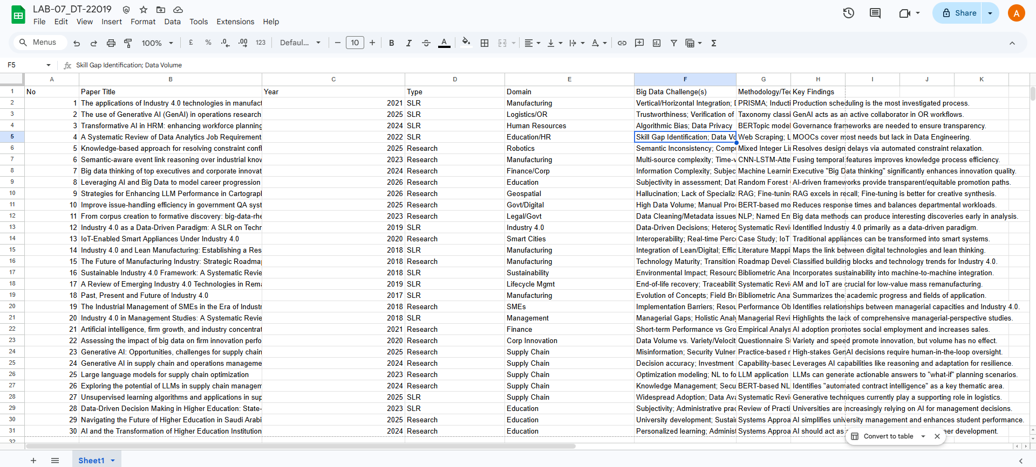

https://docs.google.com/spreadsheets/d/105ddtbf6SOWhtJGztD8wEHsnAwoe9viZJ46PAaisikw/edit?gid=0#gid=0

Task 3: SLR

Systematic Literature Review of Big Data Challenges in Industrial Systems:
A PRISMA-Compliant Synthesis

Abstract
This systematic literature review (SLR) investigates the multidimensional challenges of Big Data within industrial systems and the broader Industry 4.0 landscape. Adopting the PRISMA (Preferred Reporting Items for Systematic Reviews and Meta-Analyses) protocol, the study synthesizes current research (2024–2026) to categorize technical, cognitive, and organizational obstacles. The core objective is to map the transition from traditional industrial logic to a data-driven paradigm. Key findings highlight a critical “three-level expansion” of Big Data technology, extending from intrinsic technical growth to the transformation of human consciousness—specifically the emergence of “Big Data thinking” among top executives. The review further examines the transformative role of Generative AI (GenAI) in Operations Research (OR), particularly in bridging the gap between natural language requirements and formal mathematical optimization (NL2OPT) via frameworks like Microsoft’s Op-tiGuide. Finally, it evaluates knowledge augmentation strategies, conceptualized as referencing (RAG), internalizing (Fine-tuning), and activating (Prompt Engineering) knowledge. The synthesis reveals that while technical models such as GANs and CNN-LSTMs address data messiness and temporal dynamics, the ultimate effec-tiveness of industrial Big Data rests on the cognitive transformation of the “upper echelons” of firm management and the mitigation of risks such as the “illusion of fluency” in automated decision-making.

Introduction
The transition from traditional industrial management to the digital age represents a fundamental shift in information processing and utilization. Industrial systems are currently undergoing a “three-level expansion” driven by Big Data technology: the first level is the intrinsic expansion of the technology itself; the second pertains to its influence on microeconomic operations; and the third involves its profound effects on human behavior and thought processes [1]. This final level facilitates a transition from an era of “dialogue between humans and information” to one of “dialogue between data and data.”
This SLR addresses research questions focusing on the impact of Big Data “variety”

and the necessity for a cognitive shift in industrial innovation. Traditional “causal thinking”—based on partial information and small samples—is increasingly insufficient for complex industrial environments. The review highlights the necessity of shifting toward “correlative” and “fault-tolerant” thinking, where representativeness is valued over absolute precision, and the inherent messiness of data is embraced as a reflection of reality [1].

Research Methodology (PRISMA Protocol)

Search Strategy
The systematic search was conducted across authoritative databases (Web of Science, Scopus, IEEE Xplore, and CNRDS) to capture the intersection of Big Data, industrial management, and computational intelligence.
Table 1: Systematic Search Keywords

Category Keywords

Cognitive Frameworks Big Data thinking, Full-sample thinking, Manage-
rial Cognition
Industrial Context Industry 4.0, Supply Chain Management, Corpo-
rate Innovation
Computational Models GenAI, LLMs, GANs, VAEs, Diffusion Models, CNN-LSTM-Attention
Optimization Operations Research (OR), Mathematical Program-ming, MILP, NL2OPT

Inclusion and Exclusion Criteria
Rigorous boundaries were established to maintain academic standards:
    - Inclusion: Peer-reviewed articles from SCIE and SSCI indices; studies focusing on GenAI applications (LLMs, GANs, VAEs, Diffusion models) within industrial OR [2].
    - Exclusion: Purely predictive AI models without generative components. This follows the logic that predictive AI “interprets the known” (foresight via existing data), whereas GenAI “creates the novel” (innovation via content generation) [2].

Quality Assessment
Literature was evaluated using automated metrics and expert assessment:
    - ROUGE: Measures content fidelity between industrial requirements and gener-ated models.
    - BLEU: Assesses the precision and fluency of technical responses.
    - BERTScore: Evaluates semantic similarity in optimization constraints, cap-turing synonymous expressions where n-gram overlaps fail [3].

Thematic Analysis of Big Data Challenges

Data Variety and Information Complexity
In the era of “dialogue between data and data,” the “variety” and “messiness” of Big Data represent a shift toward valuing representativeness over precision. The challenge lies in navigating complex information environments where data is no longer a clean sample but a vast, heterogeneous entire dataset. This requires a transition from seeking elusive causal relationships to identifying robust patterns of association [1].

Cognitive Constraints and “Big Data Thinking”
Industrial leadership faces “risk aversion” in innovation, which Big Data thinking addresses through three connotations:
    - Full-sample Thinking: Shifting from random sampling to analyzing entire datasets to achieve “global awareness” and “collective intelligence” [1].
    - Correlative Thinking: Focusing on “what” (patterns) rather than “why” (causality) to improve resource integration and divergent thinking.
    - Fault-tolerant Thinking: Prioritizing representativeness over absolute pre-cision, providing a “trial and error” space essential for discovering optimal innovation solutions [1].

Technical Constraint Conflicts in Optimization
The “NL2OPT” (Natural Language to Optimization) challenge presents a significant computational and linguistic hurdle: translating unstructured industrial requirements into formal mathematical models. Microsoft’s OptiGuide workflow has emerged as a gold standard to democratize this process, utilizing a structured pipeline:
- User Question: The practitioner provides requirements in natural language.
- Question Handler: Pre-processes the query for LLM consumption.
- LLM & Interpreter: The LLM generates code and an interpreter interfaces with a traditional solver (e.g., Gurobi).
- Answer: The system identifies Irreducible Infeasible Subsets (conflicting con-straints) and provides actionable suggestions for resolution [2].

Methodological Frameworks for Resolution

Operations Research (OR) and Optimization Models
Integration of Mixed-Integer Linear Programming (MILP) with GenAI facilitates high-quality, real-time decision-making in stochastic environments.

Table 2: Comparison of Generative Models in Industrial Optimization

Model Type Primary Industrial
Role
GANs Synthetic Data Genera-tion

Industrial Application Exam-ple
Credit risk assessment in high-dimensional supply chains [2].

VAEs Probabilistic Modelling Selective Ensemble Synthesis for
patient outcomes in industrial healthcare [2].

Diffusion Stepwise Uncertainty Re-duction
Universal mobility pattern learn-ing for vehicle trajectory recon-struction [2].

Advanced Deep Learning: CNN-LSTM-Attention
Industrial systems produce high-intensity temporal data that often results in “messi-ness” (e.g., the bullwhip effect in supply chains). CNN-LSTM-Attention hybrid models are synthesized to handle these dynamics. However, as these models generate increasingly complex outputs, they create a “knowledge gap” where the raw temporal predictions require the augmentation strategies discussed in Section 4.3 to become actionable insights.

Semantic Event Reasoning and Knowledge Augmentation
Equipping industrial AI with domain knowledge follows a strategic hierarchy based on the required cognitive depth [3]:

Retrieval-Augmented Generation (RAG):
  - Concept: Referencing Knowledge.
  - Use Case: Best for Factual Fidelity. It ensures responses are fact-based and traceable by citing external documents.

Fine-Tuning (e.g., LoRA):
  - Concept: Internalizing Knowledge.
  - Use Case: Best for Creative Synthesis. It allows the model to learn the “expert tone” and implicit reasoning patterns of a specific industrial domain.

Prompt Engineering:
  - Concept: Activating Knowledge.
  - Use Case: Best for Basic Task Guidance using the model’s inherent pre-trained knowledge without parameter changes.

Discussion: Innovation and Industry 4.0 Transfor-mation
The industrial workbench is defined by an “Augmentation vs. Automation” duality. While full automation remains a distant objective, GenAI currently serves as a “co-pilot” to improve organizational capabilities, particularly for management teams lacking engineering backgrounds [1].
However, the “Illusion of Fluency” represents a significant risk. Fine-tuned models may produce stylistically expert responses that are factually impossible—for example, a model suggesting the use of “satellite data from 1950” to analyze forest cover, despite satellite technology not existing for that purpose at that time [3]. This highlights the necessity of “Human-in-the-loop” validation and the use of RAG to ground speculative generative outputs in temporal and physical reality.

Future Research Agenda
- Verification and Trustworthiness: Developing frameworks to audit GenAI-generated solutions for mathematical soundness in high-stakes decisions.
- Scalability: Balancing massive LLM sizes with the need for real-time industrial responses in resource-constrained environments.
- Privacy-Preserving GenAI: Integrating GDPR compliance and “the right to be forgotten” into industrial data mining architectures.
- Human-AI Collaboration: Investigating how the presentation of AI uncer-tainty influences human trust and the dynamics of collaborative workflows.

Conclusion
The industrial sector is transitioning from a “dialogue between humans and infor-mation” to a paradigm of “dialogue between data and data.” This SLR concludes that Industry 4.0 success is not merely a technical challenge solvable by MILP or CNN-LSTMs; it is equally dependent on the cognitive transformation of the “upper echelons” of management. Effectiveness rests on the synergy between advanced generative methodologies (like RAG and Fine-tuning) and a leadership mindset that embraces full-sample, correlative, and fault-tolerant thinking.

References
- X. Tang, Q. Liao, W. Li, and W. Liao, “Big data thinking of top executives and corporate innovation: based on machine learning,” China Journal of Accounting Studies, vol. 12, no. 4, pp. 801–838, 2024.
- Q. Zhou and J.-B. Sheu, “The use of Generative Artificial Intelligence (GenAI) in operations research: review and future research agenda,” Journal of the Operational Research Society, 2025.

- S. Wang, L. Shen, Z. Tian, T. Lan, Z. Xu, and Z. Li, “Referencing, Internalizing, or Activating Knowledge: A Comparative Analysis of Strategies for Enhancing LLM Performance in Cartography,” Annals of the American Association of Geographers, 2026.

